

***About the Client***

##### The client is an Insurance company based in USA having 500 plus employees and spread across various major cities around US. They have many lucrative customers and providing them various services through their different web/mobile app platforms. The client’s extensive fleet includes a wide range of general and sales applications running on-premises. The client was facing issues regarding company’s productivity and wanted to replicate Oracle workload & web/mobile applications to the particular cloud platforms having management configuration for their infrastructure.

**Automation of Infrastructure & Configuration for insurance company**

* The client desired flexible infrastructure on multiple cloud platforms
* Requires a centralized point of management configuration to configure services and applications
* Rapid changes can be made to infrastructure without disturbing the apps
* The client desires to migrate Oracle workload to Oracle Cloud and other web applications to AWS with complete automation

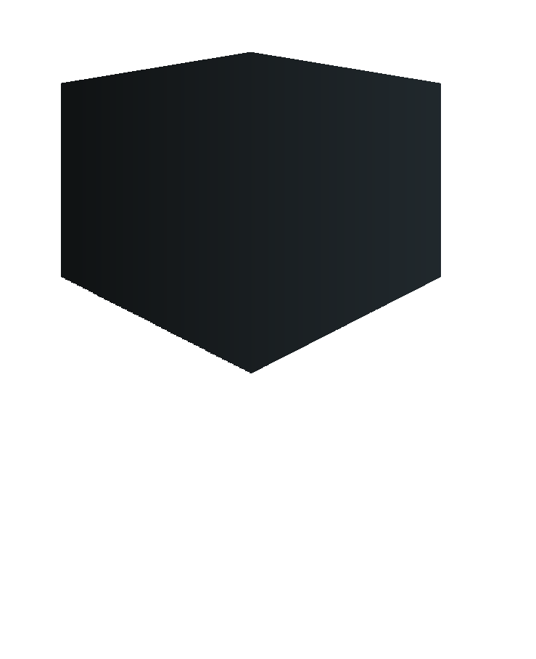At a **Glance**

### **Business Challenges**

**INDUSTRY**| Insurance

**Our Approach:**

After detailed analysis and assessment of their on-premises infrastructure by **RoyalCyber** experts team, we deployed a well managed infrastructure, following are the main services and applications which were designed and developed for the respective company:

* The DevOps team implemented their extensive script repositories to provision resources for multiple cloud platforms using Terraform
* The team used various resources of cloud to design robust and fault tolerant infrastructure
* Automation configuration was achieved by designing and implementing role based configurations using Ansible
* The change management process was deployed for the particular cloud platform
* Security and Encryption was achieved using KMS and the critical information was encrypted with Ansible Vault for access security.
* Applying infrastructure as code (IaaS) and managed configuration minimizes the access time for the data spread across the infrastructure deployed

**LOCATION** | USA

## 

Client was facing issues regarding managing their infrastructure on-premises and desired an automated solution for their cloud infrastructure

The client is an Insurance company in USA requiring an automation of their infrastructure and wanted to have robust framework on cloud.

## **CHALLENGES**

## **USE CASE**



**Results**

The client achieved the following benefits:

* 80% improvement in production on deploying new resources in cloud
* Module based infrastructure as code to help implement changes with least effect to applications
* 60% improvement in time spent in troubleshooting
* The latest infrastructure helped the customer in strategizing on their business growth
* Encrypted passwords and credentials through configuration management secured infrastructure and access



* 80% improvement in system efficiency
* 60% increase in ROI
* Speed – just in time provisioning
* Increased consistency and accuracy

Royal Cyber team automated client infrastructure on cloud and categorized infrastructure code for better business development as well as high availablability

## **KEY TAKEAWAYS**

## **SOLUTION**

**About Royal Cyber:**

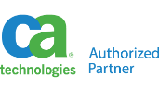

**Simplifying IT for Customers & Partners**

Royal Cyber Inc. Headquartered in Naperville, IL is a leading software organization that provides services ranging from application development and deployment to training and consultancy. We commenced the operations in the year 2002 as a specialized Technology provider striding in as a software deployment service provider, assisting clients to meet the standards and demands of doing business in the rapidly changing marketplace. Today we stand tall as a **One Stop Shop for all your IT needs.**

55 Shuman Blvd,Suite 275, Naperville, IL 60563 USA. Tel: +1.630.355.6292 Email: [info@royalcyber.com](mailto:info@royalcyber.com) [www.royalcyber.com](http://www.royalcyber.com/)